**Simple linear regression**

Simple linear regression is a regression model that estimates the relationship between one independent variable and one dependent variable using a straight line. Both variables should be quantitative. The formula for a regression line, also known as a linear regression model, is typically expressed as:



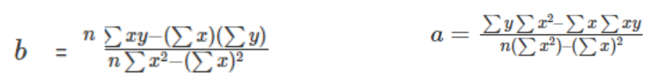

where:

y represents the dependent variable or the variable you want to predict.

x represents the independent variable or the variable you are using to make predictions.

m represents the slope of the regression line, which determines the direction and steepness of the line.

b represents the y-intercept, which is the value of y when x is equal to 0.

The goal of regression analysis is to estimate the values of m and b that best fit the data points in order to create a line that minimizes the distance between the observed data points and the predicted values on the line. This line can then be used to make predictions for new values of x.

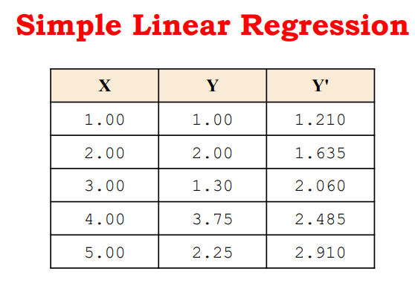 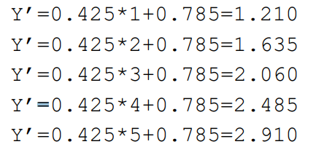

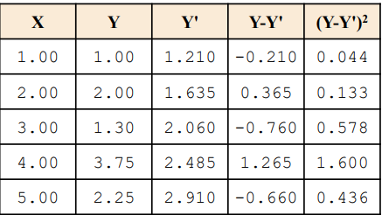

Total Error = Sum of Squares Error=2.791